**EXPERIMENT 6**

**AIM: Draw DFD (up to 2 levels) and prepare a Data Dictionary for the project**

**Project Name:** GYM Management System

**Team Members:** Gunjan Bhawsinghka (04), Pratik Chainani (06**),**

Laveen Dawani (10)

**Data Flow Diagram (DFD):**

1. **LEVEL 0 DFD:**



**2) LEVEL 1 DFD:**

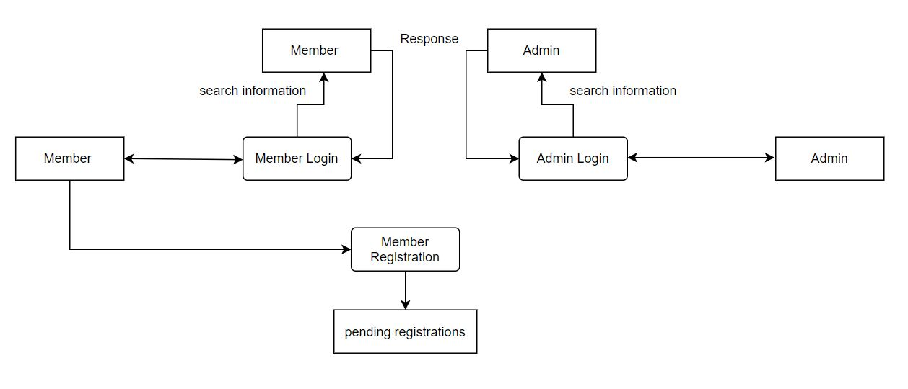

**3) LEVEL 2 DFD (MEMBER):**

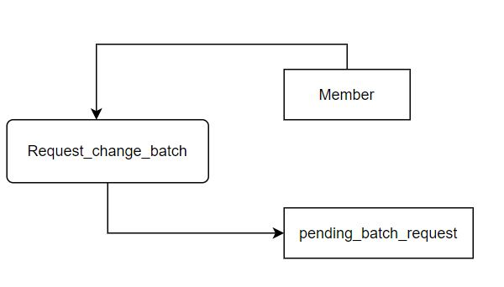

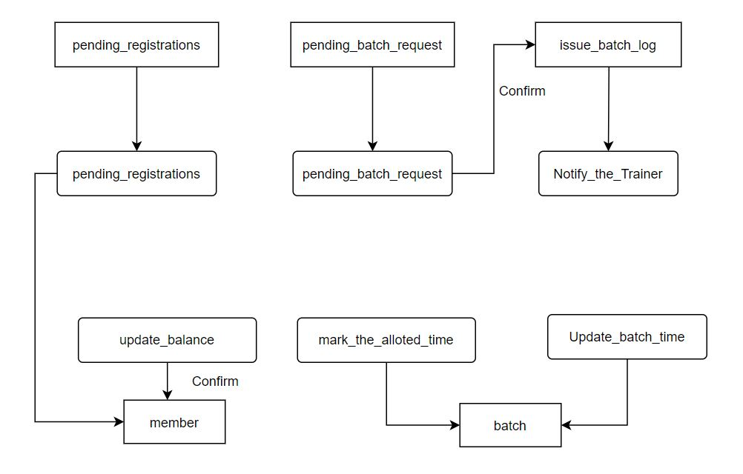

**Data Dictionary:**

